Chapter 11. Retreat to the Countryside. Villecun

In the introductory letter to Récoltes et Semailles Grothendieck writes:

After a few years of intensive anti-military and ecological campaigning of the “cultural revolution” type, that you have certainly heard echoes of here and there, I basically disappeared from circulation, lost at some provincial university God knows where. Rumor had it that I spent my time keeping sheep and digging wells. The truth is that apart from numerous other activities, I was valiantly lecturing at the university just like everybody else (this was the not very original manner in which I earned my daily bread, and it still is).

Indeed, Grothendieck “disappeared somewhere in the countryside”, and taught at a “provincial university”. Before this, however, there was a phase of transition. Let us return to the period of Survivre, in the summer of 1972.

11.1. The commune of Châtenay-Malabry

In August 1972, shortly after Grothendieck returned from his first trip to Buffalo, a project which the Survivre circle had been planning for a long time finally became reality. Already in March of that year, Grothendieck had explained in the Bulletin de Liaison that the best form of organization for Survivre's Paris group would be a commune. He imagined a big house with at least twelve rooms, which would afford space for five or six couples with children, including a room for meetings, a library, a cellar and a large garden. The place should have all “the warmth of a family environment”, and at the same time be a “meeting center”. In the bulletin containing his account of the trip to America, it is followed by information on the founding of the commune Germinal in Châtenay-Malabry:

We have found (better late than never) a large house in Châtenay-Malabry, in order to start up the commune that we have talked about for so long and which was always just getting started. It is in the rue Anatole France, No. 103, in Châtenay-Malabry, less than ten minutes from the metro station Robinson (Sceaux line). At the moment there are four members, namely Alexandre, Jacques, Justine [Skalba], Pierre.

Thanks to Jean-Claude Durand, who also resided there from time to time, the author was able to glean some information about Grothendieck in Châtenay, and later also in Olmet and Villecun. Durand is one of the people whose life was given new direction by Survivre. He had studied mathematics under Guedj, and through him came into contact with the Survivre group. Later, under the influence of the Back-to-the-Land movement he broke off his studies and turned to farming instead. He has remained with it to this day, and is a friend of Grothendieck's eldest son Serge.
“The warmth of a family environment” and “meeting center”, the expressions formulated above, are words which sound good, and which were surely conceived with the best intentions. However, some people who knew Grothendieck at this time affirm that the commune was complete chaos and that for him one of the main attractions was rather more probably “free love”. In any case, within the first days or weeks of the founding of the commune, he began to have doubts as to whether all the stressful work for Survivre or life in the commune actually made sense. A few lines after the text we find, namely:

On the other hand Alexandre believes that it might be better to largely withdraw from the mother-group [groupe-mère], including the work for the journal, and that the group would develop more spontaneously without him.

Doubtless Grothendieck soon had some very solid reasons to doubt the meaningfulness of his involvement with this commune: one day, he arrived home to find the members of the commune in the garden dancing around a fire they had kindled with his mathematical manuscripts. In the end, Grothendieck and Justine lived in the Châtenay-Malabry commune for little more than half a year. Based on an interview with Justine Bumby (née Skalba), A. Jackson relates:

[Bumby] said that he [Grothendieck] sold organically grown vegetables and sea salt out of the basement of the house. The commune was a bustling place: Bumby said that Grothendieck held meetings, which might attract up to a hundred people, about the issues raised in the Survival group, and these attracted considerable media attention. However the commune dissolved fairly rapidly as a result of complicated personal relationships among the members. It was around this time that Grothendieck's position ended at the Collège de France […]

This description of the meetings is confirmed by Durand: “There were any number of discussions about all kinds of themes, and from all points of view. Alexander experienced this sort of confusion as an essential fermentation, and he seemed to like it.”
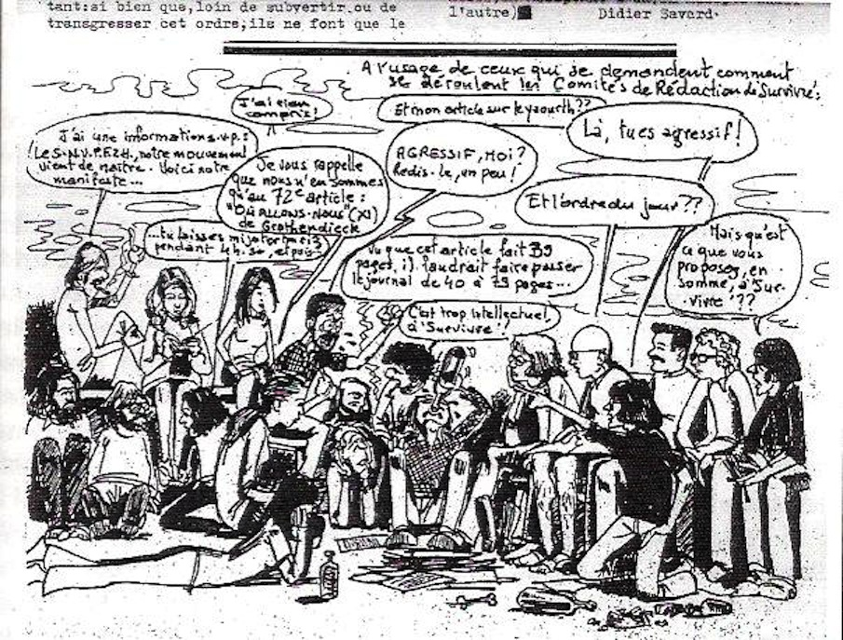

Editorial meeting in the commune Germinal about the bulletin of Survivre

Shortly after her fourteenth birthday in February 1973, Grothendieck's daughter Johanna moved into the commune, but only remained there for a short time. The conditions were dubious enough for a young girl (although she was more or less used to living on the street), that Grothendieck did not want to leave her there.
As early as 1973, the collapse of the commune was beginning to become apparent. Grothendieck was preparing his move away from the Paris area, although his activities at Orsay still required his presence. With his departure for Buffalo, the experiment Germinal ended definitively for him (probably at the beginning of April). This departure signaled the imminent end of the commune itself, which may have ceased to exist due not so much to “complicated personal relationships” than to a simple lack of funds. Indeed, Grothendieck was the only financial provider, and his sole resources were not sufficient. (In a letter to Gaeta he mentioned that they would have to take out a loan in the near future.)
A communication by Durand to the author reveals that at the beginning of 1973, Grothendieck was already preparing his departure:

At the beginning of 1973, using a Galion model Renault delivery van that had formerly served as a hearse (the property of A. although he had no driver’s license), I first organized Alexandre and Justine's move to a little house in Villecun (about two kilometers from Olmet, where no lodgings were available) and somewhat later Mireille’s move (A.'s wife from whom he was separated) with the three young children to a rented apartment in Lodève. After this, Alexandre spent several weeks on a lecture tour in the USA, and then went to Paris in order to take care of the formalities concerning his appointment to the University of Montpellier, where he began his activity at the start of term.

(We will return to the subject of Grothendieck's wife Mireille and her life during these years in Chapter 12, and again in Chapter 21.)

11.2. Villecun

Grothendieck's life once again took a radical turn when he settled in Villecun in 1973. The change was essentially one of external circumstances, and he himself may not even have realized it, but he had left Paris forever: his farewell to the city was definitive. From 1973 onwards, he only lived in small villages or in isolated houses, leaving behind every form of urban culture, inasmuch as that had ever held any significance for him. The next six years of his life were spent in Villecun.
All those who were consulted by the author remember Grothendieck in these years as a happy man: he was cheerful, he brought wine, fruit, vegetables or nuts to the common meals, he sang, helped with manual jobs, was infinitely generous (in the circle of his friends he was often called “the bank”), and his house was open to everyone; he was (at least for some years) deeply convinced of the value of the alternative lifestyle that he encountered with the region’s “breakaways” and in the rural communes. Later, in hindsight, he wrote that he had experienced this period as a “Sunday”.

Before we attempt to describe his life in this period in more detail, it is necessary to make a preliminary remark (which will certainly be relevant to other parts of this biography as well). Some of the events dealt with took place more than forty years ago, and in the memories of the people concerned many things have become blurred or displaced in time; their stories contain holes, inconsistencies and contradictions. It is often quite difficult even to identify the people involved, since they are frequently referred to by first name only, and sometimes one does not hear even that, but merely mention of “Hausel” or “Gori”. In spite of this, taken all together these accounts create a lively and vivid portrait of the period in question.
Because there is some uncertainty about the details, we will start by setting down some of the basic events from the Villecun period. When Grothendieck arrived there a lively “breakaway scene” already existed, with members from France, Germany, the USA, and other countries. These people had settled in the southern edge of the Cévennes because property in Provence had lately become too expensive. Grothendieck had learned of the existence of this scene while working for Survivre, and it was one of the main reasons for his move there. One should not, however, imagine this community as some kind of “pastoral idyll”. There is no question that some of its members were psychologically unstable people, and there were serious personal conflicts. Even in Grothendieck's closest circle there were two suicides, one of which was the occasion for a solemn night-time vigil.
The organizational and economic basis of this group was (at least) a cooperative, which acquired land and placed it at the disposal of its members for their personal use. Grothendieck was not only one of the main financial contributors to the acquisition of land, but he also financially supported individuals. To this very day some of the ex-commune members live on land paid for by Grothendieck, in houses which they then built on the property. It seems self-evident that these groups were not stable communities; people came and went, and ultimately those who stayed preferred living on their own property, and soon succeeded in having the land of the associations split up and transformed into individual ownership. This was not at all what Grothendieck, who believed in the ideal of the commune, had in mind, and he suddenly and radically pulled out of the commune and its projects.

Villecun is a picturesque little village of hardly more than a dozen houses, perched on a hillside amidst great forests. The closest town of any size is Lodève, about sixty kilometers west of Montpellier. It is perhaps typical of Grothendieck that, in this place more reminiscent of holidays than of work, he rented the smallest, darkest, and most unpractical of houses, full of fleas, without a garden or even a terrace - in fact more of a place to hide than a place to live. And the first thing he did there was to throw away his radio and switch off his electricity, henceforth writing all of his correspondence and mathematical texts by the light of a petroleum lamp. In any case, the house looks uninviting from the outside, although according to Yves Ladegaillerie, Grothendieck felt that it possessed a “soul”, and the feeling was shared by other visitors. Justine lived there for a few months with the baby John; one can imagine that it might not have been particularly comfortable to take care of a newborn baby in such conditions.
Grothendieck's lifestyle was extremely modest. He lived on produce from the local communes or individual alternative farmers. Goat’s milk, goat cheese, fresh vegetables, fruit and rice were the basic ingredients of his bill of fare. He did not sleep in a bed, but on a door taken off its hinges. His house stood open to everyone, whether he was at home or not. Many people frequented the house: friends from the vicinity and the commune of Olmet, Buddhist monks, and sometimes also his children, his students, and colleagues from Montpellier.
To reach Montpellier he needed a car. An old Citroën 2CV, “held together by wire and string”, played a role in his life at this time. As we already have heard, he had no driver's license, but this did not prevent him from driving in the least. It took him many attempts in order to finally succeed in getting a license. (His daughter Johanna says that he failed the test nine times - as with other things in Grothendieck's life, it might set a record!) Various colleagues and guests can remember instances of being driven by him and actually having doubts about surviving the adventure.
The first years in Villecun, after Justine’s departure, represented an unusual period in Grothendieck's life. It was a time of peace, and even, one is tempted to say, of equilibrium. The boundless intellectual effort of the Paris years lay behind him, and also the hectic activism of the Survivre period. The rhythm of his life slowed down; the waves became flatter and calmer. In a footnote of Récoltes et Semailles he writes of the “five years from 1974 to 1978 which were not dominated by any grand purpose, and in which manual work occupied a large part of my time and energy”.
During term, he drove to the university in Montpellier once or twice a week in order to teach his courses; he had a few graduate students and a small study group, but he did not apply himself to big mathematical projects. It seems that even his correspondence slackened in these years. The only “big” event in his life was the encounter with the Japanese monks and the resulting court proceedings, which will be dealt with in Chapters 16 and 17.
Around the year 1975 Lawrence Breen visited Grothendieck for three days in order to discuss mathematical problems. He related that Grothendieck did not speak to practically anyone from the village at that time. Only a schoolgirl from the town visited him repeatedly, in order to get help with her schoolwork. Grothendieck patiently and earnestly explained her homework to her, giving her the same attention that he would have to Deligne or any other mathematical colleague. Breen toyed with the idea of telling the girl that she was receiving instruction from the most famous living mathematician (she seemed to be unaware of this), but on second thought he refrained.
One can glean an idea of the daily life and the atmosphere in Villecun from the following account by Pierre Damphousse (see Chapter 14), who, fresh from Canada, visited Grothendieck in September or October 1975:

Grothendieck sat at his table at the end of a long and rather dark room, and worked in the dim light. Behind him piles of papers were neatly stored in boxes. In my eyes he resembled a monk writing with incredible rapidity; his pen flew over the paper. He stood up, left his workplace, and after a few words of greeting offered the nervous student some tea or an herbal infusion. I reminded him of the purpose of my visit and he decided that we would discuss the matter while taking a walk in the neighborhood.

The atmosphere in which Grothendieck lived is also made tangible in the following excerpt of a letter to his German friends dated August 4 and August 8, 1976:

[...] I have given up my gardening deeds or misdeeds for the moment. [...] The necessary long-term effort would have no point just for myself, my children don't show up at my place any more, and a life companion who might climb aboard is also not in sight at the moment. The decision was painful; it was more a necessary realization than a decision. Since the spring, I am once again totally “vacant” - and I'm not in a hurry to fill the emptiness with a new “mission in life”. For two months I did math very intensively, for lack of anything better to do, and was once again able to observe how devastatingly intense intellectual activity causes the psyche to be cut off from the flow of fresh perception of the world (the outer and the inner world [...]). Then came a remarkable time of flaming love, which filled my days and nights as seeds fill plump fruit. It was like a sonorous meditation [...] After this exalted Sunday of my life the daily routine has now set in again. I am often away from home, staying with friends from the area for one or two days, helping now and then in the garden and at construction sites, meeting new people and deepening (within my modest boundaries) my insight into those I already know. I am - as always - often stupid and sometimes alert and clear-sighted. I'm on the lookout for a companion - a woman who can love freely and without fear, and who doesn't cloak her own nature, or avoid it. [...] For this reason it is doubtful if my search for a partner (which in principle, apart from a long interruption, has already spanned the whole of my adult life […]) will ever end (as long as I live)! But even if not the desired one, the quest has born its fruits: most of what I have learned about people, I have learned through this search. The women I have loved were ultimately keys to insight. Perhaps an insight limited by lethargy - but that is what I have learned in my life.
As so often happens, this letter has grown and run rampant in the most unexpected and different directions - and how can one know whether and how some things will resonate? In this way written or spoken words are often like messages in a bottle thrown into the sea. Is the point of the message just to find someone to receive it? So few messages find their receivers!

The question remains as to why Grothendieck chose Villecun as his place of residence. Various people consulted about this were unable to give any definite information. It appears, however, that Grothendieck had been in this area on one of his “propaganda tours” for Survivre, and had established contacts with different rural communes. Also, Durand must have given him an enthusiastic account of the experiments in new lifestyles and “cultural subversion”. Furthermore, ongoing demonstrations against nuclear armament were taking place a little to the north of this location. In 1972 the French government had been planning to considerably expand the military installations already present in the almost uninhabited area of Causse du Larzac. A broad citizens' movement rose up against this, and ultimately prevented the planned expansion. The bulletin of Survivre reported several times on these campaigns.
More generally, one may wonder why Grothendieck moved south to the Montpellier area at all. Concerning this, everyone - Durand, Grothendieck's daughter Johanna, his colleagues and co-workers in Montpellier, Ladegaillerie and Contou-Carrère – agree: he was drawn back to the region where he had spent some of the years of his youth.

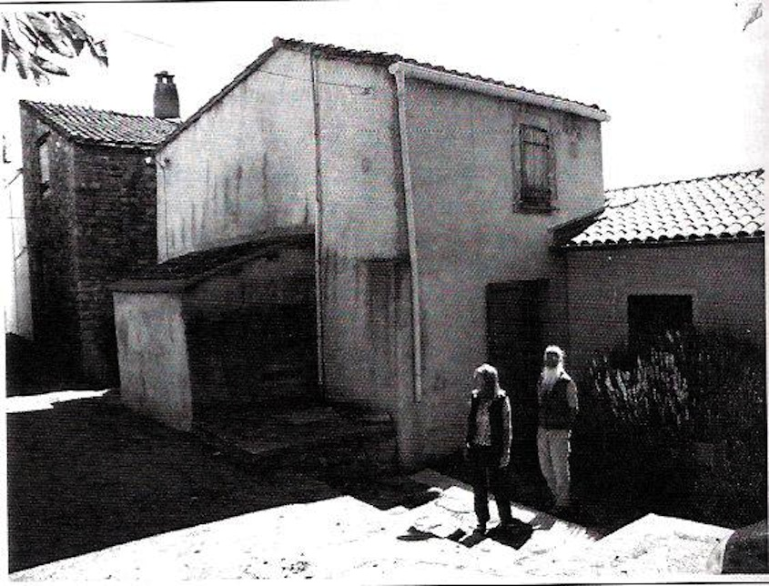

Grothendieck's house in Villecun after renovation in 2006, with his German friends E. and G.

11.3. The Commune of Olmet

We will now go back a few years to the time of the formation of the Commune of Olmet, which became an important reference point in Grothendieck's life for several years.
Very close to Villecun, perched on an isolated hill and visible at a great distance, lies the village of Olmet. At the beginning of the seventies it was presumably just a few ruined houses clustered around a church. Since then (as of 2007), these houses have been thoroughly renovated and transformed into holiday homes for well-to-do city people who spend their weekends and vacations here.
In the vicinity of Olmet, in an area overgrown with brushwood, is a commune founded by the Belgian Paul P. and his wife Lulu around the middle of the sixties. According to the P.’s, they originally acquired fifteen hectares of land which they placed at the disposal of a succession of commune members. Later on the property was almost doubled. They saw themselves as pioneers of the Back-to-the-Land movement and their four children were born in the commune and grew up there.

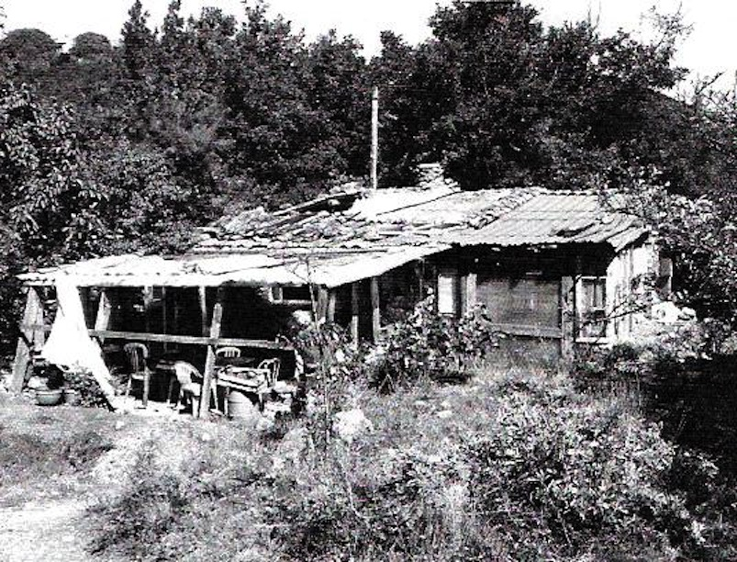

At the former commune of Olmet in 2006

During his student days Durand had already spent many months in this area of the countryside and apparently encountered the P.’s this way. In the fall of 1972 he told Grothendieck about the rural commune. Grothendieck became enthusiastic about the projects right away, and considered migrating there along with the entire “urban” commune of Châtenay. Around this same time, the P.'s (for reasons which the author does not know) were thinking of leaving the commune in Olmet and placing their land at the disposal of an experimental rural commune. The first contact between Grothendieck and the P. family, in 1972, was arranged by Durand, who then recounts further:

At this time [from the summer of 1973] a small group formed, with no members from Châtenay except for Alexandre and Justine. As far as I know these people were newcomers to the néorural movement, Elizabeth, Ghislaine, Daniel and myself. In order to be able to live on this piece of land we built cabins in the woods. We had sheep, looked after mostly by Elizabeth. Of us all, Daniel, an industrial designer, was the most qualified for the construction work. We planted a vineyard on one plot of land, and a small garden, and we kept a few beehives.
After his return [from Buffalo] Alexandre was regularly involved and active in the project, while living in Villecun with Justine and their still very tiny son John. Relationships were friendly though sometimes a little tense, particularly between Ghislaine and Daniel. We did not know which direction we were aiming at, and were hardly clear about our abilities and the requirements necessary for the realization of a utopia such as this. We did not have the indispensable practical capabilities for such a project. Alexandre was very willing to help, but confronted with such great difficulties he came to realize the unpredictability of the enterprise. His financial support and generosity made it possible for both ourselves and our ambitious project to survive: a new life on the land, in tranquil happiness and respect for Planet Earth.

In December of 1973, Durand left the commune for an extended trip. At that time, together with Daniel, he was the legal owner of the land, which they ceded to another group by the name of Le Lien. Also this group was enthusiastically supported by Grothendieck. The further destiny of the Commune of Olmet could only be partially established. What may be ascertained, and is relevant to Grothendieck's biography, is that from 1975 until at least 1978 Buddhist monks from Japan lived in the commune. More will be said about them in Chapter 16.
When Paul needed money, i.e. for a trip, he often sold a piece of land. The land became the property of a cooperative, which, as already hinted at, dissolved with the passing of years, no doubt in the course of the general decline of the hippie and breakaway movement. There was a danger that the entire property could fall into the hands of the tax authorities. Presented with this situation Pascal P., a son of Paul and Lulu, bought back the land from the cooperative for the symbolic sum of one euro. To this day he cultivates tomatoes there, and is an expert on all types of tomatoes in the world.
The P.s themselves looked for another place of residence. Several hundred kilometers to the north - in the northwest foothills of the Massif Central - they acquired a piece of land of a similar size, with a collection of ruinous houses which they are restoring, in a remote forest of chestnuts. In order to visit it, the author hiked a couple of kilometers through these woods with friends, and it is like an enchanted forest... Grothendieck's eldest son Serge, an artisan in woodworking, who at the age of 17 met Lulu while visiting his father in Villcun, lives there as well.

11.4. Breakaways and Commune Members

As members of the cooperative Le Lien, the two Rudel brothers (one of whom, Claude, died in an accident around the year 2000) belonged to the closer circle of Grothendieck's acquaintances. Claude Rudel's widow, a German, communicated the following to the author:

I never met him [Grothendieck], but my husband […] spoke of him a lot. Apparently during the seventies they belonged to a circle in which the “hippies” […] discussed ecology, anarchy and all the topics which I am finding in old issues of Survivre as I begin to read them. […] Grothendieck had given my husband and his brother - farmer's sons, who had experienced '68 not as privileged students, but already at that time as hard workers, and whose desire for freedom was even more intense because of this – 10,000 francs. Perhaps it was a kind of forgivable loan - I don't know exactly. In any case it was an enormous sum in those years, […] Claude always spoke of Alexander's social and political engagement with the utmost respect, and probably also knew his family at the time, although as a person himself committed to a moral attitude of trustworthiness and faithfulness in relationships, he was rather skeptical of Grothendieck's life choices […]

The small vineyard that was created thanks to this gift can be seen, if one wishes, as a lasting memorial to the overwhelming, spontaneous generosity which was one of Grothendieck's distinctive personality traits.

A friendly relationship also sprang up between Grothendieck and the brothers Florian and Lorenz (Lenz) G. from Munich, and Ebba P., Lorenz's wife at that time. In 1973 Ebba acquired a property near the village of Octon, which boasted a magnificent view of the surrounding hilly landscape, and on which she labored strenuously constructing accommodations. They still live there today (2010), do some farming, own two horses, geese, and chickens, and are involved in artistic projects. They belong to those few who actually realized the ideals of the breakaways and the Back-to-the-Land movement, having persevered for decades and finally created their own little world, which one may observes with admiration and almost a slight feeling of envy.
They probably met Grothendieck for the first time by chance at the market of Lodève, and this meeting was followed by mutual invitations. There were times when Grothendieck appeared at their place almost daily, always carrying a basket of food filled to bursting with organic produce; he loved to sing loudly and beautifully, and the G.'s admired his love of the truth and his openness, integrity and readiness to take on responsibility. They too know of several people who received financial support from Grothendieck; not trivial amounts, but on many occasions the price of a piece of land which would then become the basis for a “breakaway existence”.
Florian G. today (2010) still possesses a brick press that Grothendieck ordered in the USA and gave to him. This type of very simply constructed mechanical brick press was developed in the USA for US-American Foreign Aid programs, and was used for example in countries of the Sahel region. A press whose use was so simple was very helpful to the breakaways in the south of France, who wanted to build their own homes on land in remote areas. Somehow Grothendieck must have learned about the existence of this machine, and when Florian wanted to start building his own house Grothendieck ordered the machine from the US and placed it at the disposal of the hippies of the commune. He followed their work with interest, albeit without actually joining in himself. But when he suggested building an arch with the pressed (but unbaked) bricks, Florian, who had studied architecture, thought it was too risky and refused to carry out the project, thereby incurring Grothendieck's disapproval. The brick press lent useful service to generations of breakaways. It was lent out over and over again for periods of one or two years, and stands on Florian's property to this day (2010).
Ebba, the G. brothers and Grothendieck kept in touch for a long time; in the eighties, Lorenz even lived together with Grothendieck's daughter Johanna for a few years, in a village not far from Grothendieck's residence. He set up a little workshop next to Grothendieck's house. Even after Grothendieck's “disappearance” in 1991 contact was not completely broken off.

From the beginning of the seventies, Max P. also belonged to Grothendieck's circle of acquaintances. He came to know of Survivre when he was around 14, and probably met Grothendieck at one of his “propaganda lectures”. The two developed a master-disciple relationship. Among other things, Grothendieck advised the boy to break away from his parents and to lead a self-sufficient life. The Buddhist monks in the area also had a big influence on Max, and he later spent a year in a monastery (and partly in a hermitage) in Sri Lanka. He was not destined for a truly spiritual life, however, and instead brought his wife Ms. Lata back to France with him. With some difficulty, he earns a living for himself and his family as an organic horticulturalist at present, and in spite of many disappointments and conflicts he still sees Grothendieck as his guru.
The family of Pierre (now deceased) and Thérèse D. and their seven children also belong to the first generation of breakaways, who at the end of the sixties were already following the call of the “Back-to-the-Land” movement. Grothendieck financed their property, on which they still live today, with the only condition being that no chemicals would be used when building and managing the household. After Grothendieck moved away from Villecun they lost contact, and there was no correspondence. And thus today (2010) Thérèse is one of only a very few people who have exclusively positive memories of Grothendieck.

The various small groups of breakaways that have been mentioned eventually had the pertinent idea of founding a “free school” for their children. This was set up by a woman named Marie-France in the castle of Belbezé, a village neighboring Olmet. (To this day the German settlers relate with gentle irony how, while they were constructing cabins in the woods with their bare hands, the French breakaways started by buying a castle.) Grothendieck taught geometry and mathematics to children at this school for about a year.
Much later he mentioned these lessons to Michel Lazard, a friend with whom he sometimes corresponded in German. In a letter dated 16 January 1986 he writes:

Your “assumption” that for me “mathematical instruction” is limited (tacitly) to the university is totally erroneous. At the end of the forties I gave private tuition (to earn my bread). Circa 1976 I taught for around a year in a so-called “free school”, in principle once a week, mathematics among other things, to a group of about ten children between five and twelve years old. There are countless interesting mathematical questions and relationships which are understandable for a beginner (even a child) and I am amazed that you were ever at a loss. The four-color problem alone is a completely inexhaustible mine of mathematical reflection and practice, including for children of almost any age. I see no separation between mathematical reflection and insight at every “level” (such as my own reflections and questioning during school) and so-called “research”, which is attested to by publications. The mathematical thought of a child (in so far as it actually leads to a “discovery”) could be more “valuable” than a published work (inasmuch as it is mindless and joyless, a routine publication). Or rather, the one is valuable, and the other is spiritual and psychological “junk”. The essential difference for me is that between a more or less passive learning (of a material or a skill) from books for instance, and discovery, in which one's own curiosity and the corresponding stimulation of one's own creative abilities are the decisive factor. That has absolutely nothing to do with age and so-called “level”.
Polyhedra (take just the cube or even the icosahedron) are an equally inexhaustible source of mathematical reflection and insight on every “level”. I would have much more to say about my experiences concerning this […] But I feel downright silly suggesting “elementary” mathematical themes, because their amplitude seems so overwhelming to me - as if I stood in an immeasurable field and someone asked me if I would please show him a blade of grass.

To conclude this section we shall quote a very skeptical account of this period, and also of Grothendieck's personality during those years. The following quote from Allyn Jackson’s article reflects the recollections of Grothendieck’s partner Justine Skalba (now Bumby), which considerably less enthusiastic than everything else related up to now.

In early 1973 he and Bumby moved to Olmet-le-sec, a rural village in the South of France. This area was at the time a magnet for hippies and others in the counterculture movement who wanted to return to a simpler lifestyle close to the land. Here Grothendieck again attempted to start up a commune, but personal conflicts led to its collapse. […] After the latter commune dissolved, he moved with Bumby to Villecun, a short distance away. Bumby noted that Grothendieck had a hard time adjusting to the ways of the people attracted to the counterculture movement. His students in mathematics had been very serious, and they were very disciplined, very hardworking people. In the counterculture he was meeting people who would loaf around all day listening to music. Having been an undisputed leader in mathematics, Grothendieck now found himself in a very different milieu, in which his views were not always taken seriously. […]
Although most of the time Grothendieck was very warm and affectionate, Bumby said, he sometimes had violent outbursts followed by periods of silent withdrawal. There were also disturbing episodes in which he would launch into a monologue in German even though she understood no German. […]
Grothendieck may have been experiencing some kind of psychological breakdown and Bumby today wonders whether she should have sought treatment. Whether he would have submitted to such treatment is unclear. They parted ways not long after their son, John, was born in fall 1973. After spending some time in Paris, Bumby moved back to the United States.

11.5. Meditation

In Chapter 2 it was related that for Grothendieck “meditation” was one of the three passions of his life. According to his own statements he “discovered” meditation in October 1976, right in the middle of the Villecun period. He often mentions this event in his writings, though without going into details. For example, in Récoltes et Semailles p. 88 he writes:

The day in which the third great passion appeared in my life - a certain night in the month of October 1976 - the great fear of learning dissipated. It is the fear of a banal reality, humble truths concerning above all my own person, or people who are dear to me. The strange thing is that I never felt this fear in me before this night, at the age of forty-eight. I discovered it the same night that this new passion appeared, this new manifestation of the passion of knowing. It took the place, so to speak, of the fear, recognized at last.

It is not clear, (and the just quoted remarks do not shed any more light on the matter) what Grothendieck actually meant by “meditation”. In the “Letter of Good News” (see Chapter 29) he writes:

A second act of essential significance follows in 1976, with the discovery of so-called “meditation”, with which my thirst for discovery and knowledge turned to the discovery of myself and my psyche.

It is equally unclear whether and how much it altered his daily life, or in what way it changed the direction of his thoughts. With due caution one might perhaps suggest that there was a turning inwards. All of his life Grothendieck had been an extrovert, a charismatic personality who dominated his surroundings. During his time as a mathematician he was an undisputed authority, who gave direction to a whole generation of students. Hectic activism characterized the Survivre period. But now Grothendieck began - no doubt partly as a result of multiple disappointments - to look inwards. He reflected on his youth, his parents, he delved into their correspondence, and he gradually began to lead a “spiritual” life. Religious questions, such as the purpose of man in this world, became important to him. A few years after he had discovered meditation, he began writing down the long series of his mathematical or philosophical meditations or reflections, all of which were the result of long, intensive contemplation and reliving, and whose structure was no longer determined through the stringent structures of a science like mathematics. (It should be noted at this point that by “meditation” Grothendieck meant something completely different from what is meant in Buddhism, in which he would soon develop an interest.)
In connection with the writing of the long meditation La Clef des Songes (see Chapter 24), Grothendieck made a list of the most important spiritual events in his life. As this list will often be referred to, the original in French is shown here in its entirety, although most of it may not seem relevant at the moment.

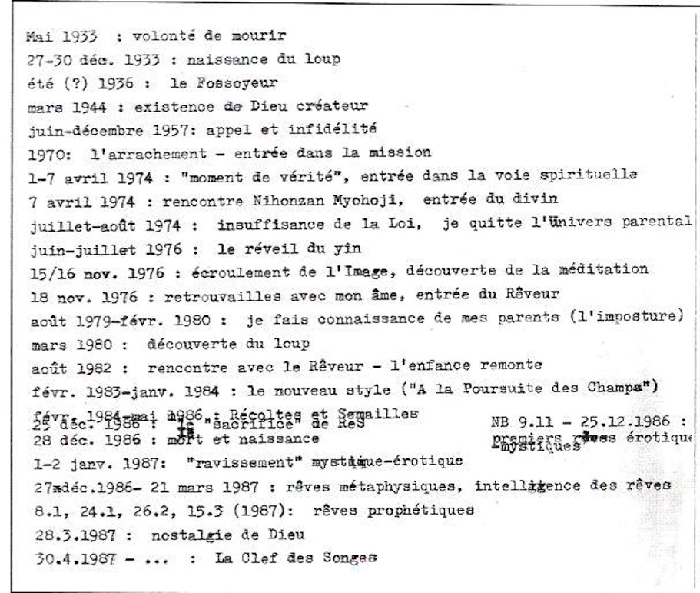

It is almost impossible to decode these cryptic remarks, and at this point we will say little about them. We do note, however, the three entries concerning the year 1976:

June-July 1976: the awakening of the Yin

15/16 Nov. 1976: collapse of the Image, discovery of meditation

18 Nov. 1976: reunion with my soul, entry of the Dreamer

It is here that Yin-Yang duality appears for the first time: it became a concept of crucial significance in Grothendieck's world view, and is frequently mentioned in his letters. Perhaps Grothendieck himself would say that a transition took place within him, from a life influenced by Yang to one influenced by Yin.

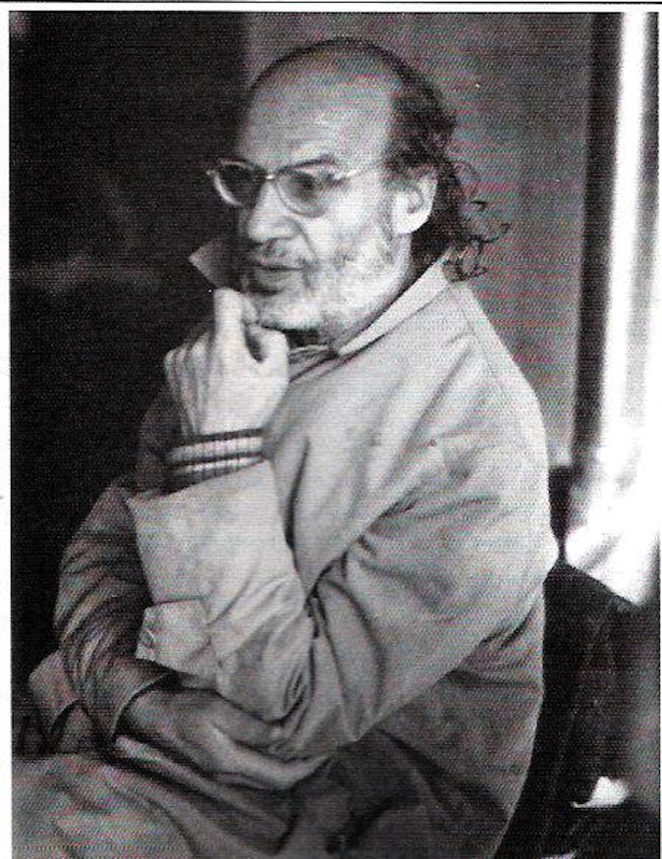

Who were Jacques (Jesus) and Pierre. Also, as of 2009 the house apparently no longer exists.
This must in fact have been some years later.
Other witnesses are certain that Grothendieck had good and friendly contacts with the inhabitants of Villecun, an example of how different and contradictory memories can be.
e-mail to the author, June 2010.
Here Grothendieck refers to his courses in Montpellier at the end of the seventies. (see Chapter 13). The enthusiasm with which Grothendieck writes about this subject is somewhat surprising. His complete, or almost complete failure to interest students in research and playful discovery in the sense sketched out, particularly in his course on the cube and icosahedron, was a decisive reason for him to stop teaching in Montpellier and switch back to a position at the CNRS in 1984.

