**Chapter 19. La Gardette and *Éloge de l’Inceste,* 1979-1980**

Grothendieck moved out of his house in Villecun at the beginning of July 1979, because it had become too “lively” by his own account, and withdrew to a “lonely retreat” in the Vaucluse. For about a year he lived not far from Gordes (around fifty kilometers east of Avignon) in La Gardette, residing in the vacation house of the well- known ethnologist Robert Jaulin mentioned in Chapter 6, who had been a fellow campaigner during the *Survivre* period. The house is situated in the arid landscape of Provence, completely isolated amidst holy oaks and juniper bushes. At that time the property possessed no electricity, running water or sanitary facilities. Since then, holiday homes in the area have become a favorite choice among wealthy city dwellers. When searching for the property in 2008 the author even discovered a private heliport in its immediate vicinity.

Grothendieck kept his new place of residence “top secret”. From a footnote in *La Clef des Songes,* one can deduce that for the first time in his life he spent more than a year in almost complete solitude. Although during this “particularly bountiful year” (as he wrote in a letter) he deliberately sought this solitude, he did keep up an intense correspondence with his friends and acquaintances His German friends E. and G. received at least twelve letters with substantial content. As an indication of how great his need for peace and solitude was, though, he kept his whereabouts hidden even from Y. with whom he had been involved in a passionate relationship for over a year (see next chapter).

This move to La Gardette also marked a vital change in his life: about half a year earlier he had begun writing the meditation *Éloge de l'Inceste*, and this writing now became the main focus of his life. Perhaps it was more or less by chance that at the same time he began to critically examine his parents’ correspondence. In any case, he it was in La Gardette that he started to read through it systematically. In *Récoltes et Semailles,* he mentions that this occupied him from August 3, 1979 to March 1980. It is not clear to what degree these two occupations, the reading of his parents' letters (and probably the text of *Eine Frau*) and his work on the *Éloge,* influenced each other[1]. In any case in a letter to E. I. and G. J. dated August 17, 1979 he gives the following account of both of them.

Since the beginning of July I have been digging into the letters and notes of my parents - which begin more or less in the twenties. A pretty big mountain that I am plowing through - since \the beginning of August that is all that I have been doing. I would never have thought that I would thus learn so much about my father and about my mother - because I did not know just how superficial and lacking in any depth my image of them was. It was to some degree just an important component of my own self-image. Only now, when these “images” are disappearing am I learning to see them correctly. And this is no doubt a prelude to a deeper understanding of myself.

In that same letter and numerous others, Grothendieck reported on his work on his first ever “reflection of a philosophical nature”, the *Éloge de l'Inceste*, with which he was intensively occupied for about a year. He refers to it as a poem or a song, and mentions it occasionally in his other meditations, where he excuses himself for the title being “a bit sensational” (“*un peu tapageur”*). In order to preclude any misunderstandings, let us state from the outset that the *Éloge* has hardly anything in common with what one usually means by a “poem”: it belongs to a literary category of a completely unique kind. Only a few pages of the typescript have actually been found, and for now, it must be considered as lost. As has already been said, Grothendieck probably burned it, although it is also possible that one of the copies that Grothendieck sent to acquaintances has survived destruction.

In his letters, he says among other things that a first version of the text was completed in July 1979, and that he intended to proofread it in depth (together with an unidentified friend) and type up a fair copy. Just as he did later with *Récoltes et Semailles,* he then meant to have it duplicated and sent out to his friends and acquaintances: “I'm curious to see if there will be any echo, and of what sort.” In fact, however, none of this ever happened. Although he was convinced that the *Éloge* was the “most significant” thing that he had ever undertaken in his life, he was undecided regarding publication. In the end, he made only a handful of copies, which he gave to just a few friends to read. Then he decided against publication and requested that all the existing manuscripts be returned to him. Presumably, only a very small number of people ever read the entire text. One person close to Grothendieck shared the following concerning this “song of praise”.

He wrote the text when he was still in Villecun and gave it to me to read; later he took it back. It seemed to me to be a very strange text. He [Grothendieck] spoke of the love relationship between mother and son, not as a real event in his life, but as a theoretical possibility for a love, which, although forbidden by society, is precious and beautiful. He also gave the text to a friend who felt it to be deceptive that Schurik did not speak of his feelings for his mother and their real relationship, but instead developed a sort of theory. When he [Schurik] lived in Gordes, before he came to Les Aumettes, he spent a lot of time reading the correspondence between his father and mother. This changed something within him. Afterwards he decided not to show anyone the text of L’*Éloge de l'Inceste* any more, and asked me to return the manuscript[2]. I even think that he burned everything, along with the letters of his parents.

If Grothendieck delayed the decision about whether to publish, it was perhaps in part due to the fact that his thoughts were already elsewhere, namely with *Récoltes et Semailles* and even *La Clef des Songes*. *La Clef des Songes* frequently refers to *l'Éloge*, and he speaks of a trilogy intended for publication consisting of *L'Éloge*, *Récoltes et Semailles* and *La Clef des Songes*. The central theme of this trilogy was to be the creativity inherent in humankind and the universe, where “creativity”, especially in the final part, was also to be understood as the working of God through humanity and in the universe. In his original words, he intended this as

...une longe réflexion sur la créativité dans l'homme et dans l'Univers [...] Ainsi, dans les trois œuvres successives *L'Éloge, Récoltes et Semailles, La Clef des Songes*, qui toutes trois développent le thème central de la création, l'accent se trouve mis à tour de rôle sur l'aspect charnel, intellectuel (ou plus généralement, mental), et spirituel de la créativité. Cela reflète bien sûr une évolution intérieure, avec un déplacement correspondant de mes intérêts et investissements dominants, dans le sens d'un dépouillement et d'une maturation spirituelle.[3]

The three aspects mentioned here - the physical, the intellectual and the spiritual - are of fundamental significance to Grothendieck's philosophical thinking. If one were to attempt to make a systematic presentation of Grothendieck's philosophy and world view, this threefold classification would be a central issue, along with Yin/Yang dualism and the work of God or a “creative intelligence” in the universe.

As has already been said, Grothendieck referred frequently to the *Éloge* in letters to his German friends at the time, and expressed himself in detail about his plans and the ideas which came to him during the writing of this “song”. There is no lack of humor and self-irony in his remarks:

I have just now altered the title page for the eighty-third time, and indeed, this time for the sake of variety I have somewhat un-embellished it.[4]

In order to give a brief impression of the text, most of which is lost, let us reproduce a few lines from the surviving Epilog. In one of his letters, Grothendieck questions himself as to whether the text might not be a little “pompous”; a legitimate question indeed.

*I. L’acte*

*1. L'Acte est retour à la Mère.*

Pour l'amant, l'amante est la Mère, et son élan vers elle est élan de retour vers le Giron dont il est né - dont toute chose est née. C'est l'irrésistible élan de la naissance à rebours: retourner dans le Giron accueillant de la Mère.

L'amante vit l'Acte comme la Mère qui accueille l'enfant bienaimé revenant en Elle. Mais elle-même aussi retourne à la Mère - elle retourne en Elle-même, en son propre giron qui est aussi le Giron ... le lieu où tout son être en l'Acte afflue et se recueille.

*2. L'Acte est une mort*

L'extinction, la mort dans le Giron de la Mère est l'aboutissement ardemment désiré du Jeu d'Amour de l'amante et de l'amant, la naissance à rebours n'est-elle aussi extinction, aboutissant en la mort de l'amante et de l'amant dans le silence sans bornes du Giron?[5]

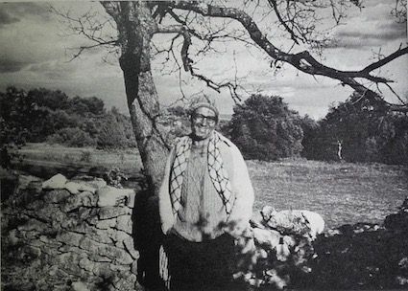

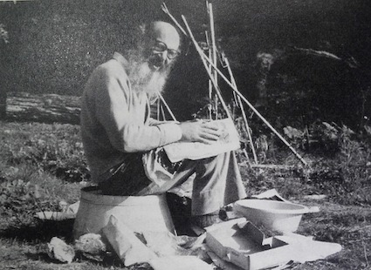

Grothendieck at La Gardette

Although at first Grothendieck wanted to keep his residence in Gordes a secret, he eventually received many visits, including from his two eldest children.

I was about to say something particularly Profound and Pertinent - I was in the process of turning my tongue seven times in my mouth in order for it to come out Powerfully (PPP) when I saw a bearded silhouette flit by the window, searching, and it soon became clear that it wasn't coming to haunt one of my two earnest neighbors, but indeed, no other than myself. [...] Who was it? My son Serge, whom you know of by hearsay as a Guru-Maharadji-freak. So in the end I unexpectedly celebrated Christmas within the trusted family circle, just as one should. We sat almost until morning before a lovely fire burning in the fireplace, chatted, fell silent, and feasted on apples and nuts. It did both of us a lot of good to speak of certain things, in particular from the past (whose effects still continue), which up until now had never come up between us. The same thing happened with Johanna and me; recently she spent ten days here with her little daughter Samara-Samba, in order to get a few days of necessary distance from her marital bliss [...] Her husband Ahmed then came too, for another three days, [...]

This sounds like a family idyll, but Grothendieck then (yet again) begins to brood and twist things around.

The whole meditation only makes sense insofar it has an effect of clarification and resolution on me and (thus also) on my relationships to the people around me. Above all, my relationships to the members of my family (especially to my children, their mothers and my sister) are particularly weighed down by Karma, which I myself for the most part received from my beloved parents in my young years. And my present work on reaching an understanding of my parents is revealing itself to be, although I vaguely guessed it, nevertheless of unexpected and ever more astounding significance. [...] And the conversations in the last month of this particularly bountiful year are a reminder to me of the importance and urgency of this next stage, which still lies before me in its entirety.

An impressive photograph of Grothendieck from this “lonely year” sets one thinking. It shows him as an almost Faustian figure, in front of a stone wall at his crudely fashioned work table. In front of him lies the death mask of his mother, and to the right and left are piles of folders, apparently filled with letters, manuscripts or similar documents. One would so gladly take up these folders, open them and begin to read...

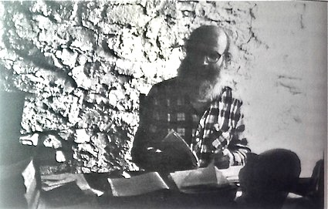

Grothendieck in La Gardette, around 1980

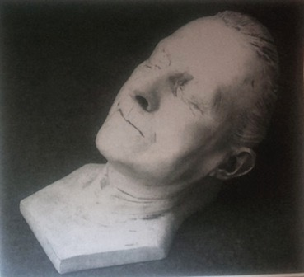

Death mask of Hanka Grothendieck

1. Later, when Grothendieck had already moved to Mormoiron, he had the typed manuscript of *Eine Frau* bound with great care; some of the page numbers and chapter titles are marked in Grothendieck's handwriting, and numerous additional pages with corrections and additions by Hanka Grothendieck have been fitted into precisely the right places.
2. This remark seems mistaken; from Grothendieck's correspondence it emerges that even after having read his parents' correspondence he went on sending the *Éloge* to friends and acquaintances, or at least intended to do so.
3. …a long reflection on creativity in man and in the Universe [...] Thus, in the three successive works *l'Éloge, Récoltes et Semailles*, *La Clefs des Songes*, all three of which develop the central theme of creation, the accent is placed in turn on the carnal, the intellectual (or more generally, mental), and the spiritual aspect of creativity. This of course reflects an inner evolution, with a corresponding displacement of my dominating interests and investments, in the direction of shedding, and of spiritual maturation.
4. The German word is *entschnörkelt.* This kind of expression iscertainly special to German, although similar things can be done in French.
5. *I. The Act*

   *1. The Act is a return to the Mother*

   For the lover, the beloved is the Mother, and his thrust towards her is the thrust of returning to the Source from where he was born - from where all things are born. It is the irresistible thrust of a birth in reverse: the return to the welcoming Source of the Mother

   She, the lover, experiences the act as the Mother who receives the beloved child returning into Her. But she too returns to the Mother, rediscovers the Mother - she returns into herself, into her own source which is also the Source ... the place into which all her being flows and collects itself in the Act.

   *2. The Act is a death*

   Extinction, death in the Source of the Mother is the climax so ardently desired by the lovers' Game of Love, is not birth in reverse also an extinction, climaxing in the death of the lovers within the limitless silence of the Source?